**Ideation Phase**

**Brainstorm & Idea Prioritization Template**

| Date | 31 june 2025 |
| --- | --- |
| Team ID | LTVIP2025TMID28960 |
| Project Name | Automated Car Catalog System For Enhanced Showroom Management |
| Maximum Marks | 4 Marks |

**Brainstorm & Idea Prioritization Template:**

Brainstorming is the creative foundation that powers innovative solutions. It fosters a collaborative space where all ideas are welcome—whether conventional or out-of-the-box. For a project as dynamic and forward-thinking as the Automated Car Catalog System, a successful brainstorming session should allow team members to freely explore concepts that can elevate showroom management through automation and digital intelligence.

This template is designed to help you and your team unlock your imagination, explore a wide array of solutions, and collaboratively shape ideas that lead to practical innovations. The focus here is not just to find a single perfect idea but to encourage a volume of ideas, enhance team synergy, and refine concepts through shared feedback. Whether you're working in the same room or remotely, this structure ensures everyone’s input is captured and valued.

Use this space to let your creativity flow—identify new features, improve catalog design, enhance customer interaction, or streamline the request and delivery process. Prioritize feasibility, but don’t shy away from futuristic ideas that can redefine showroom experiences.

**Step-1: Team Gathering, Collaboration and Select the Problem Statement**

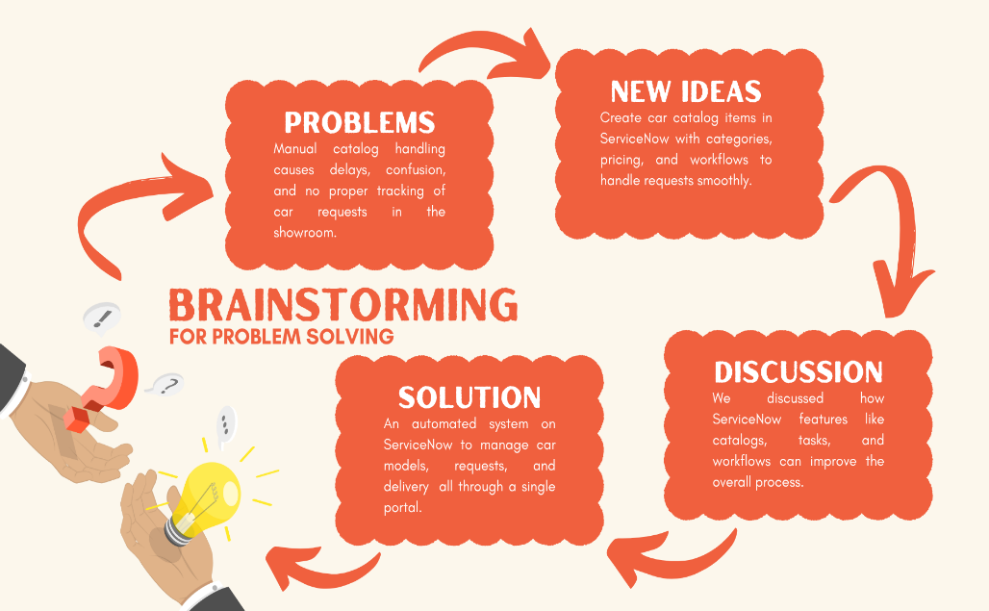

**Step-2: Brainstorm, Idea Listing and Grouping**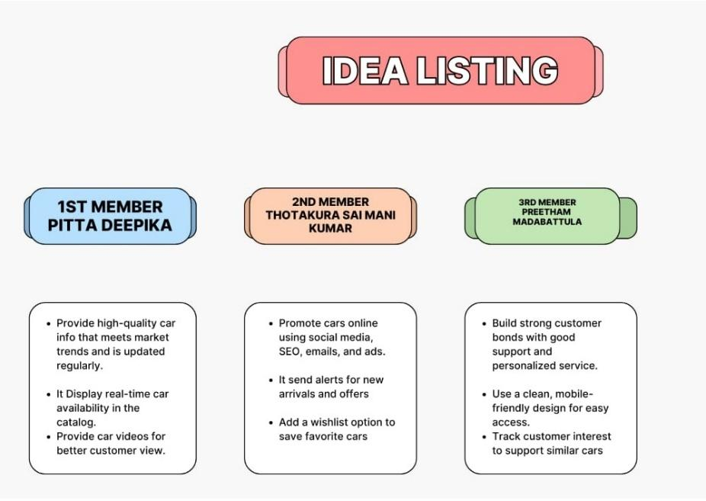

* **Brainstorming:**

Team members shared ideas openly, encouraging creativity and active involvement without any judgement.

* **Idea Listing:**

Every idea shared is noted down to make sure nothing is missed or forgotten.

* **Grouping:**

Similar ideas are grouped together to find patterns and set clear priorities.

* **Action planning:**

Selected ideas are turned into tasks with clear steps, roles, and deadlines.

**Step-3: Idea Prioritizatio**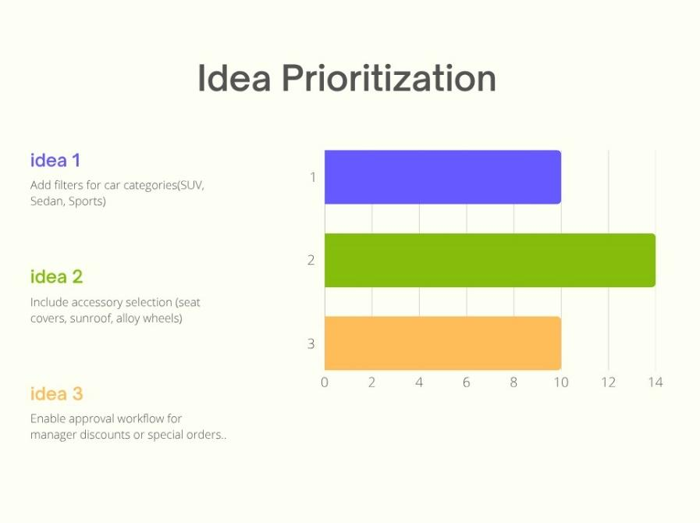

**Idea Prioritization:**

In the Automated Car Catalog System, ideas are assessed based on their impact on customer experience and operational ease versus the effort required to implement them. Features like car category filters and accessory selections are considered high-impact and low-effort, making them top priorities for quick improvement. This prioritization helps the team focus on smart upgrades that deliver maximum showroom value with minimal development effort, ensuring a smooth, efficient, and personalized user experience.